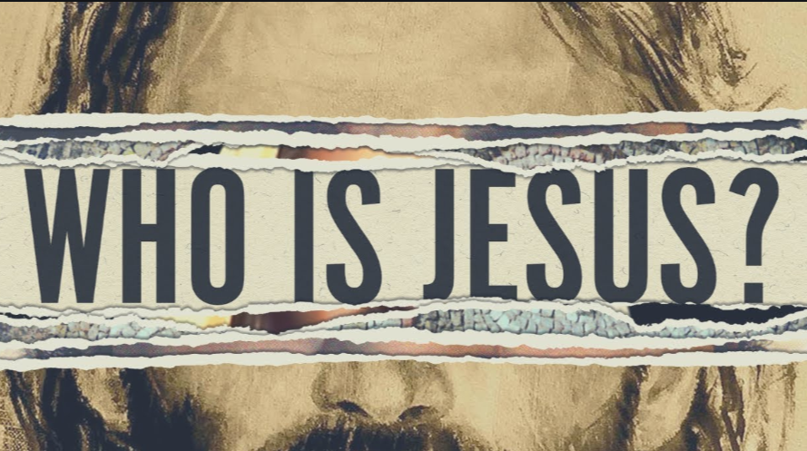

More than a Carpenter
By Josh McDowell

What Makes Jesus Different?

Lenten Adult Forum
with Cynthia Pigéon

Is Jesus a Religion?
After this, Jesus went out and saw a tax collector by the name of Levi sitting at his tax booth. “Follow me,” Jesus said to him, and Levi got up, left everything and followed him. Then Levi held a great banquet for Jesus at his house, and a large crowd of tax collectors and others were eating with them. But the Pharisees and the teachers of the law who belonged to their sect complained to his disciples, “Why do you eat and drink with tax collectors and sinners?” ~ Luke 5:27-32

Who is Jesus?
Jesus answered them, “It is not the healthy who need a doctor, but the sick. I have not come to call the righteous, but sinners to repentance.

What makes Jesus different?
They said to him, “John’s disciples often fast and pray, and so do the disciples of the Pharisees, but yours go on eating and drinking.”

What is the Church? Is it a Religion?

Why do people get uncomfortable when hearing Jesus name?

- What is in a Name?

What are Christians?

More Than a Carpenter
2,000 years ago Jesus entered the human race. He was a member of a poor family, part of a small Jewish community, and a resident of one of the smallest countries in the world. Most of his 33 years on earth he was a carpenter, following in the profession of his step-father. His last three years were spent in public ministry.

Who did Jesus claim to be?
The distinct claims of Jesus to be God eliminate the popular idea that he was just a good moral man or a prophet who said lots of profound things. For example…

He forgave sins—something only God can do.
“When Jesus saw their faith, he said to the paralytic, ‘Son, your sins are forgiven.’ Now some of the scribes were sitting there, questioning in their hearts, ‘….Who can forgive sins but God alone?’” (Mark 2:5-10).

He claimed equality with God.
“I and the Father are one,” Jesus said. When the religious leaders prepared to stone him to death, Jesus asked, “I have shown you many good works from the Father; for which of them are you going to stone me?” They answered, “It is not for a good work that we are going to stone you but for blasphemy, because you, being a man, make yourself God” (John 10:30-33).

He claimed to be the only way to God.
“I am the way, and the truth, and the life. No one comes to the Father except through me” (John 14:6).

Jesus asked his disciples, “Who do you say that I am?” It is a question that every one of us must answer now…or when we face God at the final judgment: “It is appointed for man to die once, and after that comes judgment” (Hebrews 9:27). Thankfully, the Bible says that whoever believes in Jesus Christ, the Son of God, as their Savior “is not condemned.” But it warns that “whoever does not believe is condemned already, because he has not believed in the name of the only Son of God” (John 3:18).

